*STUDENT NAME: V.SUBASREE*



*REGISTER NO :astvu22922924u18042*

*NM ID:E7C0D67223E914CB55341F573D036*

*DEPARTMENT: B.SC.COMPUTER SCIENCE COLLEGE: SRI BHARATHI WOMENS ARTS AND*

*SCIENCE COLLEGE*

*UNIVERSITY:THIRUVALLUVAR UNIVERSITY*

1



* *The* ***student Digital Portfolio*** *is a personal web- based platform created to showcase my* ***skills****,* ***achievements****, and* ***projects*** *. It is developed using basic web technologies:* ***HTML****,* ***CSS****, and* ***JavaScript****. The portfolio reflects my identity as a* ***Computer Science student****.*

2



* 1. *Project statement*
  2. *Project overview*
  3. *End Users*
  4. *Tools and Technologies*
  5. *Portfolio design and Layout*
  6. *Features and Functionality*



* 1. *Results and Screenshots*
  2. *Conclusion*
  3. *Github Link*

3/21/2024 **Annual Review**



3



* *In today's digital age, individuals—especially students and athletes—often struggle to present their* ***skills****,* ***achievements****, and* ***career highlights*** *in a structured, accessible, and professional format. Traditional resumes or paper portfolios are* ***limited****,* ***static****, and often fail to showcase one's full potential, especially when it comes to* ***multi-disciplinary profiles.***
* *There is a* ***need for a digital platform*** *that allows individuals to create a*



***personal brand****, highlight both* ***academic and***

***extracurricular achievements****, and provide* ***contact options for***

opportunities in employment, sports, or collaboration.

4



## summary:

The Online Quiz Application is a web-based platform built with HTML, CSS, and JavaScript. It allows users to take quizzes and receive instant feedback. The project demonstrates basic front-end skills like navigation, form handling, and interactive design.



* *What your portfolio contain(Home,About me,project,skills,contect).*

## Main idea:

showcase personal achievement,skills and project.

5



* ***Recruiters and Employers:***

***Why they use it****: To assess your technical skills, personal qualities, and achievements before offering a job or internship.*

***What they look for****: Skills section, education, personal introduction, and overall presentation*

* ***General Public / Online Visitors:***

*Anyone curious to know more about my profile.*

*Can reach out through the contact form for queries or opportunities.*

* ***Students*** *– Attempt quizzes, get scores*

***Admins*** *– Manage quiz content*

***Visitors*** *(optional) – Preview or demo access*

6



## HTML (Hyper Text Markup Language):

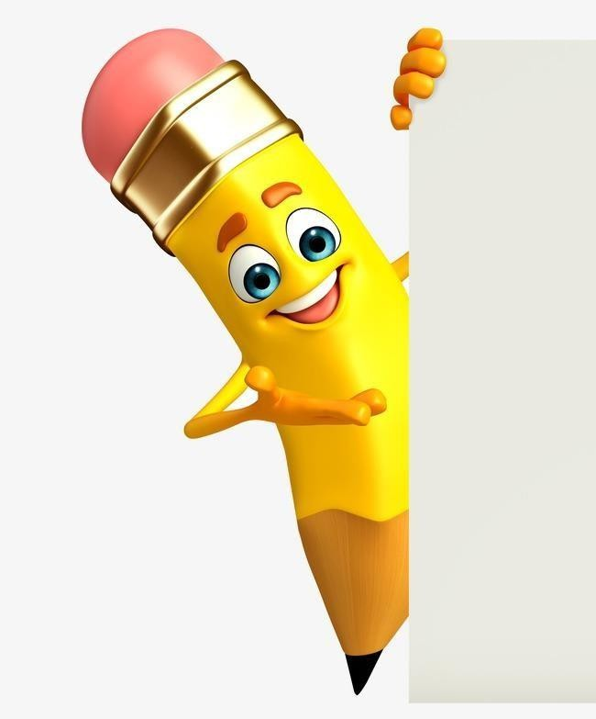

Used to structure the content of the webpage.

## CSS (Cascading Style Sheets):

Used to style the webpage (colors, layout, fonts, spacing,

responsiveness).

## JavaScript (Basic):

***.Used for:***

.Navigation between sections

.Handling form submission

.Showing success messages

7



## Header Section:

**.**Displays your name, profile photo, and professional tagline.

.Uses a center-aligned layout with a colored background for visual impact.

. Profile picture is styled to be circular using:

## Navigation Bar (Navbar):

.Horizontal menu with links: About Me, Projects, Contact.

.Implemented using Flexbox (display: flex; justify-content: center;) for alignment.

.Color-coded: dark background (#333) and hover effect (#990073).

## Main Content Area (Container):

.Uses <section> elements for different pages (Home ,About ,skills, Projects,

Contact).

.Only one section is visible at a time, toggled by JavaScript function show Section(id) the using visual studio code.

8

## About Me Section

***Split into two subsections:***

.Personal introduction

.Skills listing (structured with <p> tags)

## Projects Section

.Each project is placed inside a .project div:

.Background: white Border & shadow: creates a card-like appearance

.Rounded corners using:

## Contact Section Clean layout with:

.Input fields and text area stacked using flex-direction

.column A submit button styled with hover effects

## Footer:

.Simple, center-aligned footer with consistent brand color.

* + ***Response layout is desktop view***



***Features:***

* + - ***Responsive Design:***

The portfolio is optimized for various devices and screen sizes.

## Project Showcase:

I have a section to display your projects with descriptions.

## Skills Section:

I listed your technical skills and proficiencies.

## About Me:

A brief bio **a**nd introduction to who you are and what you do.

## Contact Form:

A way for visitors to get in touch with you.

# Functionality:

## Navigation Menu:

A functional navigation menu to switch between sections.

## Section Display:

Sections are displayed and hidden dynamically using JavaScript.

## Form Submission:

The contact form submits successfully and displays a confirmation message.

## Smooth User Experience:

The portfolio provides a smooth and engaging user experience.

# Additional Features:

## Image Display:

I included images in your portfolio.

## Footer:

A footer with copyright information.



* + - *Screenshots of each section*



* + - *Hence vs After HTML- > with CSS & JS*

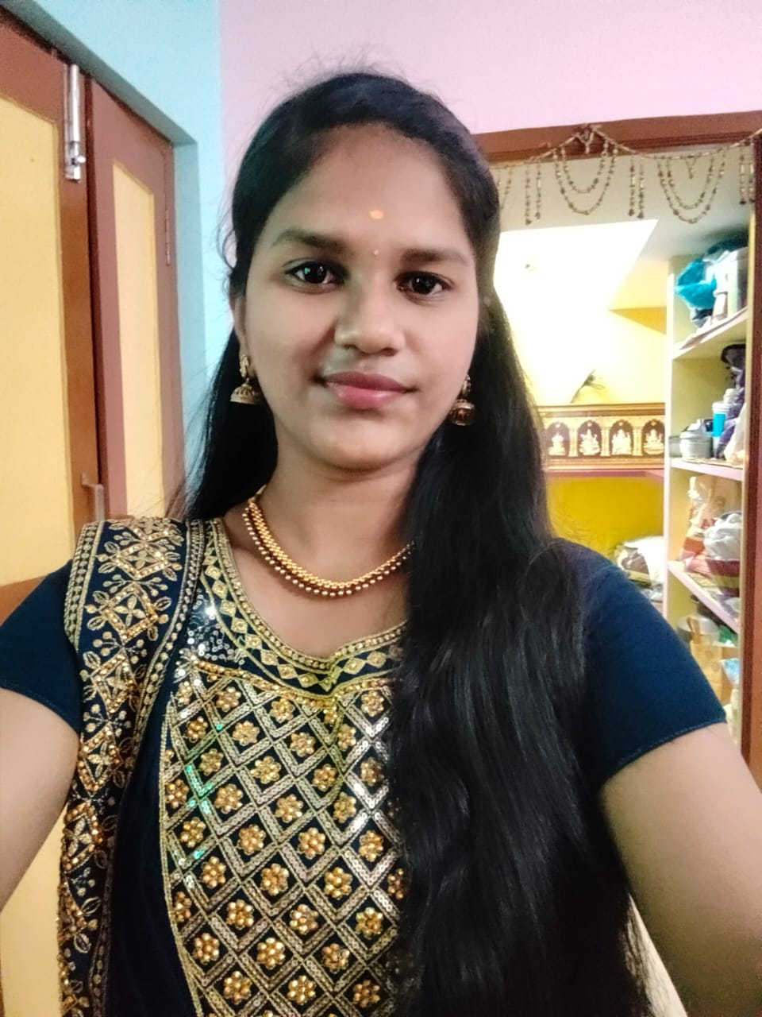

Hello and welcome! I’m V.subasree — a passionate web developer, creative designer, and a dedicated state-level handball player.

This portfolio is a reflection of my journey in both technology and sports. Here, I find information about my background, technical skills, academic projects, and my achievements in handball.

Whether you're here to explore my development work, discuss collaboration, or learn more about my experience as a sportsperson, I'm glad you stopped by! 12

About Me

Hello! I’m V.subasree, a Bachelor of Science in Computer Science student with a strong passion for technology, innovation, and continuous learning.

Throughout my academic journey, I’ve developed a solid foundation in programming, web development, databases, and software

design. I enjoy solving real-world problems through logical thinking and creative solutions.

Alongside my studies, I actively build projects to apply my knowledge in practical ways — from web-based applications to simple

games. I’m eager to learn new technologies, collaborate with others, and contribute to impactful projects in the tech space.

As a tech enthusiast and a team player, I strive to improve my technical and interpersonal skills every day, preparing myself for a dynamic career in the software and IT industry.

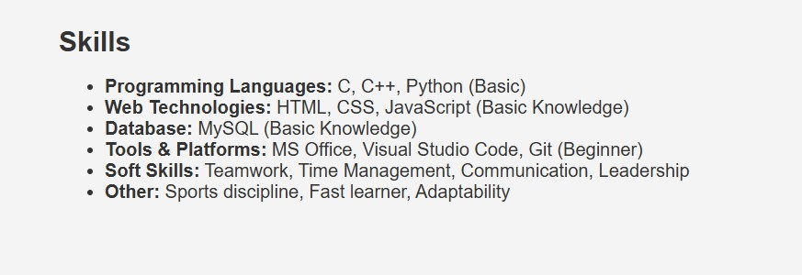

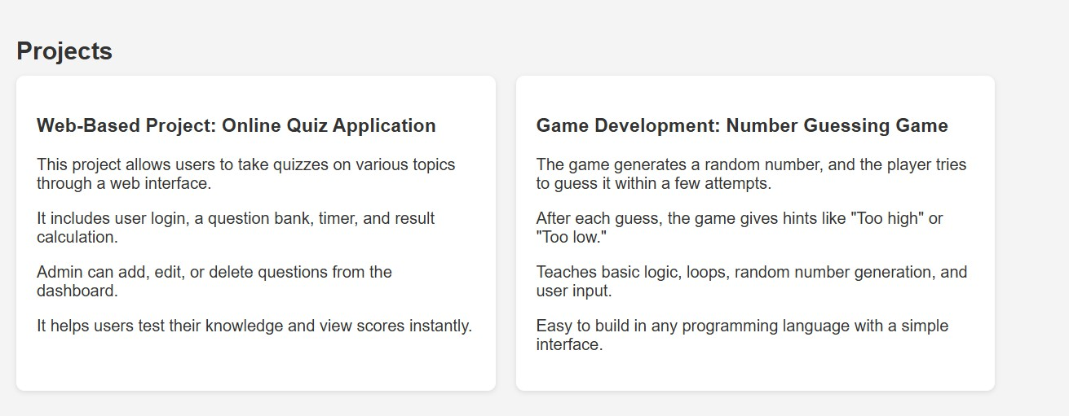

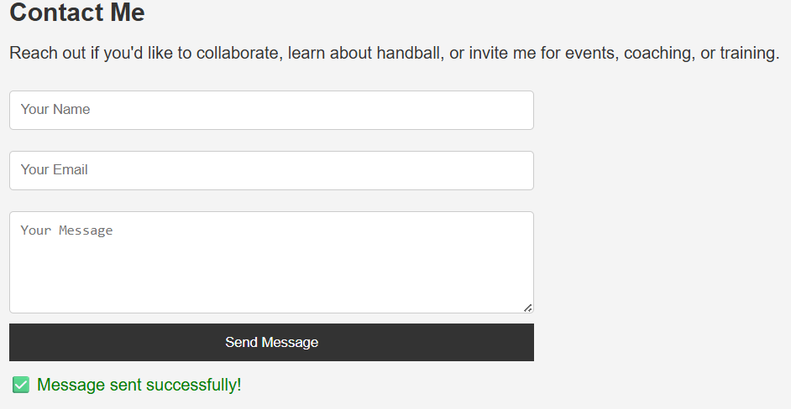



* *My digital portfolio effectively showcases your skills and experience in web development, with a clean design and functional features. By highlighting your projects, skills, and contact information, you've created a valuable resource for potential employers or collaborators. With some minor enhancements, your portfolio can continue to grow and showcase your expertise in the field.*
* *This portfolio showcases my journey, achievements, and dedication in both sports and technology, reflecting my passion for growth and excellence.*



16